**Pizza Sales Analysis SQL Portfolio Project:**

**1) Total Sales:**

select round(sum(p.price*od.quantity),0) as total_sales

from order_details od

join pizzas p

on od.pizza_id = p.pizza_id

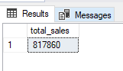

**2) Total Quantity:**

select sum(quantity) as total_quantity

from order_details

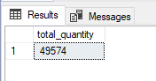

**3) Average Order Value:**

select round(sum(p.price*od.quantity)*1.0 / count(distinct od.order_id),2) as average_order_value

from order_details od

join pizzas p

on od.pizza_id = p.pizza_id

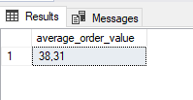

**4) Total Order Count:**

select count(distinct order_id) as total_order_count

from order_details

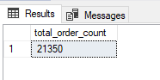

**5) Average Orders per Day:**

select count(distinct order_id) / count(distinct date) as average_daily_order

from orders

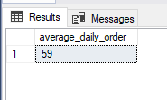

**6) Daily Sales and Orders Trend:**

select

datename(weekday, o.date) as days,

round(sum(p.price*od.quantity),2) as sales_by_day,

count(distinct o.order_id) as order_by_day

from orders o

join order_details od

on o.order_id = od.order_id

join pizzas p

on od.pizza_id = p.pizza_id

group by datename(weekday, o.date)

order by sum(p.price*od.quantity) desc

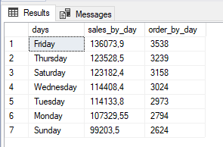

**7) Monthly Sales and Orders Trend:**

select

datename(month, o.date) as days,

round(sum(p.price*od.quantity),2) as sales_by_month,

count(distinct o.order_id) as order_by_month

from orders o

join order_details od

on o.order_id = od.order_id

join pizzas p

on od.pizza_id = p.pizza_id

group by datename(month, o.date)

order by sum(p.price*od.quantity) desc

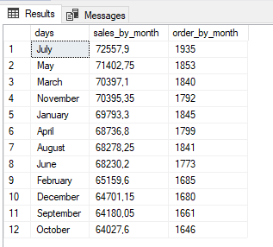

**8) Hourly Sales and Order Trend:**

select

datepart(hour, o.time) as days,

round(sum(p.price*od.quantity),2) as sales_by_month,

count(distinct o.order_id) as order_by_month

from orders o

join order_details od

on o.order_id = od.order_id

join pizzas p

on od.pizza_id = p.pizza_id

group by datepart(hour, o.time)

order by datepart(hour, o.time)

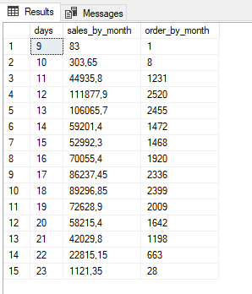

**9)Sales and Quantity by Category:**

select

pt.category,

sum(od.quantity) as quantity_by_category,

round(sum(od.quantity*p.price),2) as sales_by_category,

round(sum(od.quantity*p.price)*100.0 /

(select round(sum(p.price*od.quantity),0) as total_sales

from order_details od

join pizzas p

on od.pizza_id = p.pizza_id),2)

as percentage_by_category

from pizza_types pt

join pizzas p

on pt.pizza_type_id = p.pizza_type_id

join order_details od

on p.pizza_id = od.pizza_id

group by pt.category

order by sum(od.quantity*p.price) desc

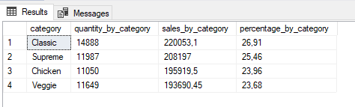

**10) Sales and Quantity by Size:**

select

p.size,

sum(od.quantity) as quantity_by_size,

round(sum(od.quantity*p.price),2) as sales_by_size,

round(sum(od.quantity*p.price)*100.0 /

(select round(sum(p.price*od.quantity),0) as total_sales

from order_details od

join pizzas p

on od.pizza_id = p.pizza_id),2) as percentage_by_size

from pizzas p

join order_details od

on p.pizza_id = od.pizza_id

group by p.size

order by sum(od.quantity*p.price) desc

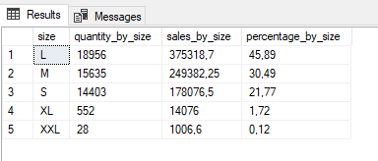

**11) Top 5 Product by Quantity and Sales:**

select top 5

pt.name,

sum(od.quantity) as quantity_by_product,

round(sum(od.quantity*p.price),2) as sales_by_product

from pizza_types pt

join pizzas p

on pt.pizza_type_id = p.pizza_type_id

join order_details od

on p.pizza_id = od.pizza_id

group by pt.name

order by sum(od.quantity*p.price) desc

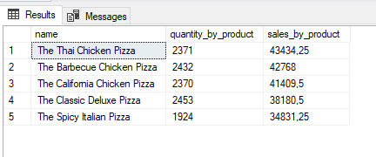

**12) Bottom 5 Product by Quantity and Sales:**

select top 5

pt.name,

sum(od.quantity) as quantity_by_product,

round(sum(od.quantity*p.price),2) as sales_by_product

from pizza_types pt

join pizzas p

on pt.pizza_type_id = p.pizza_type_id

join order_details od

on p.pizza_id = od.pizza_id

group by pt.name

order by sum(od.quantity*p.price)

